EXP 35

AIM:

Design DFA using simulator to accept strings in which a’s always appear tripled

INPUT:

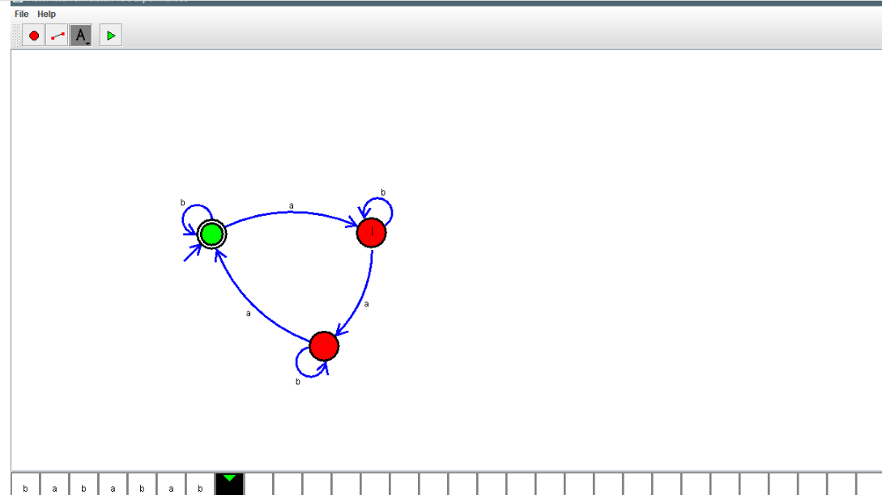

OUTPUT:



RESULT: Design DFA using simulator to accept strings in which a’s always appear tripled is verifoed